

Lab Report on

Array and string

**Course Title:** Structured Programming Language Lab

**Course Code:** CSE 112

**Date of Submission: 06.01.19**

**Submitted by:**

**Name :** Syeda Nowshin Ibnat

**ID :** 17183103020

**Intake :** 39

**Section :** 01

**Program :** B.Sc. in CSE

**Submitted to:**

**Name:** Md. Hasibur Rahman

Lecturer,Dept. of CSE at

Bangladesh University of Business and Technology.

Lab-8(array and string programs)

Objective:♦ To learn problem solving skills of array and string in c.

**Prog-1**

**Title:** A C program to find number of vowel and consonant in a given string.

**Source Code:**

#include <stdio.h>

int main()

{

char str[100];

int i, vowels, consonants;

i = vowels = consonants = 0;

printf("Enter any letter:");

gets(str);

while (str[i] != '\0')

{

if(str[i] == 'a' || str[i] == 'e' || str[i] == 'i' || str[i] == 'o' || str[i] == 'u' ||

str[i] == 'A' || str[i] == 'E' || str[i] == 'I' || str[i] == 'O' || str[i] == 'U')

{

vowels++;

}

else

consonants++;

i++;

}

printf("\nNumber of Vowels = %d", vowels);

printf("\nNumber of Consonants = %d", consonants);

return 0;

}

**Output:**

Number of vowel and consonant of a string

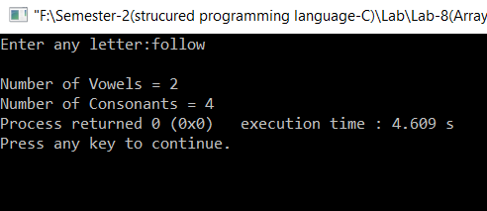

**Prog-2**

**Title:** A program to check whether a string is palindrome or not.

**Source Code:**

#include<stdio.h>

#include <string.h>

int main()

{

char s1[20], s2[20];

int i,n, length = 0;

printf("Enter string: ");

gets(s1);

for (i = 0; s1[i] != '\0'; i++)

{

length++;

}

for (i = length - 1; i >= 0; i--)

{

s2[length - i - 1] = s1[i];

}

for (n = 1, i = 0; i < length; i++)

{

if (s2[i] != s1[i])

n = 0;

}

if (n == 1)

printf("%s is a palindrome.", s1);

else

printf("%s is not a palindrome", s1);

return 0;

}

**Output:**

Palindrome check of a string

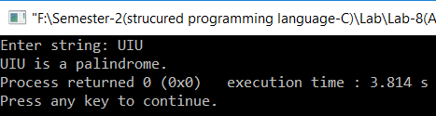

**Prog-3**

**Title:** A C program to sort elements of array in ascending order.

**Source Code:**

#include <stdio.h>

int main()

{

int a[50],n,i,j;

printf("Array size: ");

scanf("%d",&n);

printf("Elements: ");

for(i=0;i<n;i++)

{

scanf("%d",&a[i]);

}

for (int i = 0; i < n; i++)

{

for (int j = 0; j < n; j++)

{

if (a[j] > a[i])

{

int tmp = a[i];

a[i] = a[j];

a[j] = tmp;

}

}

}

printf("\nAscending : ");

for (int i = 0; i < n; i++)

{

printf(" %d ", a[i]);

}

return 0;

}

**Output:**

Array sorting in ascending order.

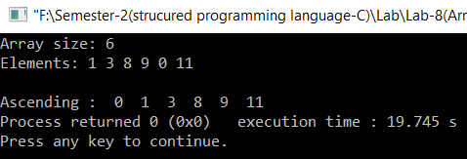

**Prog-4**

**Title:** A C program that shows the multiplication of two matrixes.

**Source Code**:

#include<stdio.h>

int main()

{

int a[5][5],b[5][5],c[5][5],m,n,p,q,i,j,k;

printf("Enter rows and columns of first matrix:");

scanf("%d%d",&m,&n);

printf("Enter rows and columns of second matrix:");

scanf("%d%d",&p,&q);

if(n==p)

{

printf("\nEnter first matrix:\n");

for(i=0;i<m;++i)

for(j=0;j<n;++j)

scanf("%d",&a[i][j]);

printf("\nEnter second matrix:\n");

for(i=0;i<p;++i)

for(j=0;j<q;++j)

scanf("%d",&b[i][j]);

printf("\nThe new matrix is:\n");

for(i=0;i<m;++i)

{

for(j=0;j<q;++j)

{

c[i][j]=0;

for(k=0;k<n;++k)

c[i][j]=c[i][j]+(a[i][k]*b[k][j]);

printf("%d ",c[i][j]);

}

printf("\n");

}

}

else

printf("\nError! Matrix multiplication can't be done");

return 0;

}

**Output:**

Matrix multiplication.

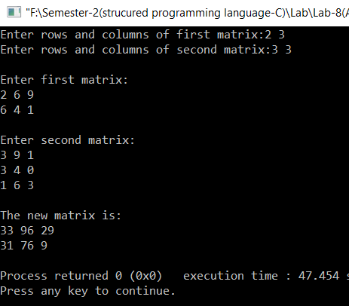

**Prog-5**

**Title:** A C program to change case from upper to lower in a string.

**Source Code:**

#include <stdio.h>

#include <string.h>

int main()

{

char s[50];

int i;

printf("In Upper case:");

gets(s);

for(i=0;s[i]!='\0';i++){

if(s[i]>=65&&s[i]<=92){

s[i]=s[i]+32;

}

}

printf("\nIn Lower case:%s",s);

return 0;

}

**Output:**

Upper case to lower case conversion of a string.

